**AWS Learning Journey: Introduction to Cloud Computing**

**1. What is Cloud Computing?**

Cloud computing is the on-demand delivery of IT resources over the internet with pay-as-you-go pricing. Instead of owning and maintaining physical data centers and servers, you can access computing services like storage, databases, servers, and networking on an as-needed basis from cloud providers.

**Key Benefits of Cloud Computing:**

* **Cost-Efficiency**: Eliminates the need for investing in physical hardware, reducing capital expenditures.
* **Scalability**: Easily scale resources up or down depending on demand.
* **Reliability**: Cloud providers offer high availability and redundancy, ensuring minimal downtime.
* **Global Access**: Access resources and services from anywhere with an internet connection.

**2. Types of Cloud Services (Cloud Service Models)**

Cloud services are categorized into three main models, often referred to as **"X-as-a-Service"**:

**a. Infrastructure as a Service (IaaS):**

* Provides basic cloud infrastructure such as virtual machines, storage, and networks.
* Example: Amazon EC2 (Elastic Compute Cloud)
* **Use Case**: Best for users who want control over their hardware, OS, and applications but without managing physical infrastructure.

**b. Platform as a Service (PaaS):**

* Delivers a platform allowing developers to build applications without worrying about underlying infrastructure.
* Example: AWS Elastic Beanstalk
* **Use Case**: Ideal for developers who want to focus on creating applications without dealing with infrastructure management.

**c. Software as a Service (SaaS):**

* Provides fully functional software applications delivered over the internet.
* Example: Gmail, Salesforce
* **Use Case**: Best for users who want to use a complete product without managing the backend.

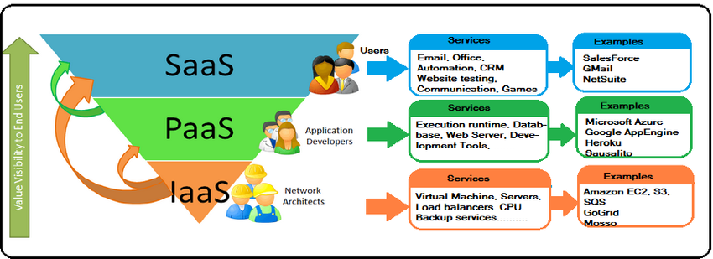

**3. Cloud Deployment Models**

Cloud deployment models determine how cloud services are delivered and used. There are three main models:

**a. Public Cloud:**

* Services are delivered over the internet and shared among multiple users (multi-tenant).
* Example: AWS, Microsoft Azure, Google Cloud.
* **Use Case**: Suitable for businesses that require scalability and cost-effectiveness with minimal infrastructure management.

**b. Private Cloud:**

* Cloud services are used exclusively by a single organization (single-tenant).
* **Use Case**: Best for organizations that have strict security or compliance needs and prefer more control over their infrastructure.

**c. Hybrid Cloud:**

* Combines public and private clouds, allowing data and applications to be shared between them.
* **Use Case**: Suitable for businesses that need flexibility, combining the benefits of both public and private clouds.

**4. Why Cloud?**

Cloud computing has become essential for modern businesses and developers due to several advantages:

**a. Cost Savings:**

Cloud providers offer a pay-as-you-go model, reducing the need for large upfront investments in hardware. You only pay for the resources you use, which helps control costs and predict spending.

**b. Flexibility & Scalability:**

Cloud resources can be scaled up or down easily depending on the business's current needs. This flexibility allows organizations to handle varying workloads without investing in additional infrastructure.

**c. Global Accessibility:**

Cloud services can be accessed from any location with an internet connection, enabling collaboration among distributed teams and global operations.

**d. Innovation & Speed:**

Cloud providers offer tools and services that help businesses innovate faster by providing access to advanced technologies such as AI, big data, and machine learning, which can be used without having to build infrastructure from scratch.

**5.Hypervisors:**

A **hypervisor**, also known as a **virtual machine monitor (VMM)**, is a software, firmware, or hardware that creates and manages virtual machines (VMs). It allows multiple operating systems to share a single hardware host, with each OS running its own virtual machine. The hypervisor controls the system's resources, allocating the necessary CPU, memory, storage, and network resources to each virtual machine while ensuring isolation between them.

**Types of Hypervisors:**

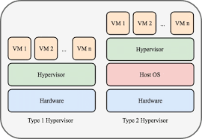

1. **Type 1 (Bare-Metal Hypervisor)**:
   * Directly runs on the host's hardware, replacing the host operating system.
   * More efficient as it interacts directly with the physical hardware.
   * Common in enterprise environments.
   * **Examples**:
     + VMware ESXi
     + Microsoft Hyper-V
     + Xen
2. **Type 2 (Hosted Hypervisor)**:
   * Runs on top of an existing operating system (the host OS).
   * The host OS manages the hardware, while the hypervisor manages the virtual machines.
   * Easier to set up but generally less efficient than Type 1 hypervisors.
   * **Examples**:
     + VMware Workstation
     + Oracle VirtualBox
     + Parallels Desktop

**Key Functions of a Hypervisor:**

* **Resource Allocation**: Distributes hardware resources like CPU, memory, and storage among virtual machines.
* **Isolation**: Ensures that each virtual machine is isolated from others, preventing them from interfering with each other.
* **Virtualization**: Creates an abstraction layer that allows multiple operating systems to run simultaneously on the same hardware.
* **Migration**: Allows virtual machines to be moved from one physical server to another without downtime (live migration).

**Use Cases of Hypervisors:**

* **Server Consolidation**: Multiple VMs running on fewer physical servers to reduce costs.
* **Cloud Computing**: Cloud providers use hypervisors to create, manage, and allocate VMs for customers.
* **Development & Testing**: Developers use VMs to test software on different OS environments without needing multiple physical machines.